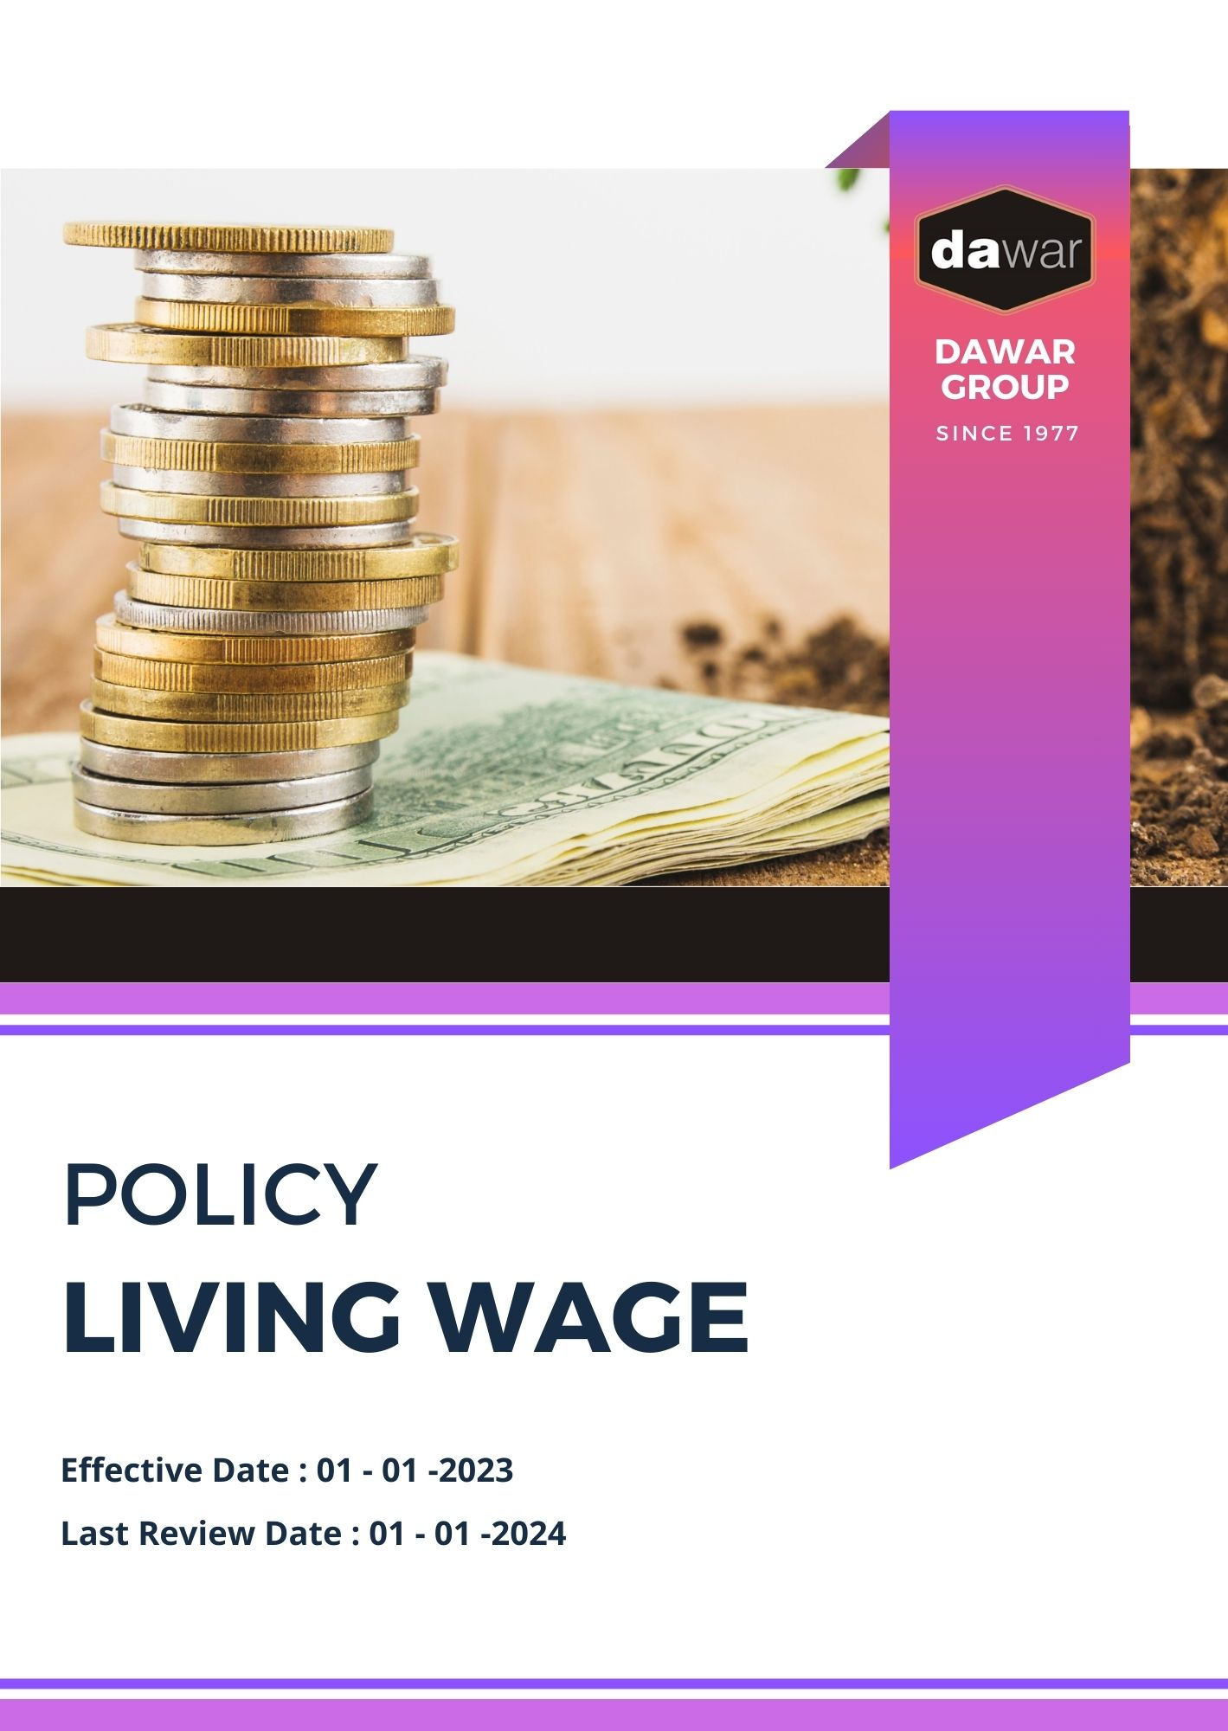

Table Of Contents

A. Why It Matters 3
B. The Dawar Group Way 3
C. Scope 3
D. What's Expected 4
E. Dawar Group’s Living Wage Commitment 4
F. Governance and Allocation of Responsibilities 5
G. Reporting Section 6
H. Covered SDGs 7
I. Review Mechanism 7
J. Dawar Group Living Wage Policy Employee Acknowledgement Form 8

Why It Matters
Dawar Group is committed to ensuring fair compensation for all employees, promoting economic stability, and extending our commitment to living wages across our entire supply chain. This commitment is not only an important social responsibility but also creates value for our business, customers, stakeholders, and employees by fostering a motivated and productive workforce. As part of our sustainability-driven mission, we believe that fair wages contribute to a more equitable society and help combat global inequalities, aligning with our vision to create a greener and more socially responsible future.

The Dawar Group Way
It is the policy of Dawar Group to compensate our employees with a living wage that allows them to meet their basic needs and those of their families. This includes fair remuneration, benefits, and working conditions that promote dignity and economic security. We extend this commitment across our value chain, encouraging our suppliers and partners to adopt similar practices in line with our vision for sustainability and social responsibility.

We set annual goals, develop necessary capabilities, and commit appropriate resources to achieve this policy through fair labor practices, operational efficiency, and aligning Dawar Group's supply chain with this policy.

Scope
This policy applies to all employees, stakeholders, contractors, partners, customers, contractual workers, and anyone acting on behalf of following sites:

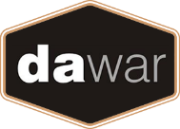 | Dawar Group
 | Address: Near Bapu Asaram Asaram, 12.5 Km, Agra-Delhi Road, Sikandra, Agra-282007 (India)
 | https://www.dawargroup.com/about-us/

What's Expected
- Living Wage Compliance
Dawar Group complies with all applicable labor laws and regulations, while also striving to provide wages that exceed minimum requirements. We foster employee engagement, set performance standards, and utilize a Wage Management System to drive compliance and continuous improvement, including through:
- Implementing a living wage calculation methodology that factors in the local cost of living, inflation rates, and family size;
- Providing flexible benefits packages that include health care, retirement savings, and parental leave;
- Ensuring wage equity across gender, race, and experience levels, and creating equal pay for equal work policies;
- Establishing a transparent pay structure that allows employees to understand how their pay is determined and how they can progress within the company;
- Supporting continuous skills development and training programs for career growth opportunities;
- Managing subcontractors and suppliers to ensure they meet living wage standards across the entire supply chain;
- Promoting industry-wide living wage standards, and advocating for their broader implementation among peers and partners.

Dawar Group’s Living Wage Commitment
- Establishes 2022 as the Baseline year for measuring progress and achievements in our sustainability initiatives.

- Living Wage Implementation:
- 100% of direct employees will receive a living wage by 2026, using a global living wage benchmark calculator adapted for regional contexts.
- We plan to extend living wage standards to 80% of our tier 1 suppliers by 2026, and 100% of tier 1 suppliers by 2026.
- We intend to implement a performance-based wage progression system, allowing employees to increase their wages based on skill development and tenure, with a target of reaching 125% of the living wage by 2026.

- Benefits Enhancement:
- We aim to ensure that 100% of employees are enrolled in healthcare coverage that includes medical, dental, and vision insurance by 2026.
- Dawar Group plans to provide a company-matched retirement savings plan of 6% of annual salary by 2026.
- Paid parental leave will be increased to 18 weeks for primary caregivers and 6 weeks for secondary caregivers by 2026.

- Wage Equity:
- We aim to achieve a maximum 8:1 ratio between the highest and lowest-paid employees for 100% of our workforce by 2026.
- Dawar Group intends to completely eliminate gender pay gaps across all departments and job levels by 2026.
- We plan to roll out transparent pay scales and career progression paths across the organization by 2026, ensuring fair and equal opportunities for all employees.

Governance and Allocation of Responsibilities
The Living Wage Policy at Dawar Group outlines a comprehensive governance framework to ensure fair compensation practices are adhered to throughout the organization and supply chain. Below is the structured governance model and responsibilities for implementing and overseeing the policy
- Board of Directors:
- Oversees the overall living wage strategy and approves long-term fair compensation goals.
- Ensures alignment of living wage initiatives with business objectives and stakeholder expectations.

- Chief Human Resources Officer (CHRO):
- Leads the development and implementation of the Living Wage policy across the organization.
- Reports on living wage performance and progress towards targets.

- Fair Compensation Committee:
- Oversees day-to-day living wage operations and compliance.
- Coordinates with various departments to integrate fair compensation practices and ensure policy adherence.

- All Employees:
- Adhere to the policy and participate in living wage training programs.
- Report any wage-related concerns or discrepancies to the Fair Compensation Committee.

Reporting Section
At Dawar Group, transparent and effective reporting is essential for communicating our progress on living wage initiatives to all stakeholders, including employees, customers, investors, and regulatory bodies. The key components of our reporting mechanism are as follows :
- Living Wage Performance Metrics:
- Conduct annual evaluations of key living wage indicators, including wage levels, benefits coverage, and equity metrics.
- Utilize advanced data collection tools and surveys to ensure accurate and real-time data on employee compensation.
- Prepare and review monthly reports comparing performance against established living wage targets and baseline data.

- Annual Living Wage Report:
- Publish a comprehensive annual report that provides a thorough overview of our living wage initiatives, achievements, challenges, and future goals.
- Highlight successful programs, such as wage increases and benefits enhancements.
- Engage an independent third-party auditor to verify the accuracy and reliability of the report, enhancing credibility and transparency.

- Wage Discrepancy Reporting:
- Implement a robust system for reporting and managing wage discrepancies or concerns.
- Provide monthly summaries of reported issues, including detailed investigations and corrective actions taken to address and prevent recurrence.

- Community and Stakeholder Engagement Reports:
- Document our community outreach and stakeholder engagement efforts related to living wage initiatives, detailing participation and impact.
- Collect and compile feedback from stakeholders on our living wage performance and initiatives, using it to inform continuous improvement.

Covered SDGs
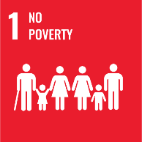 |  | 

Review Mechanism

The Chief Human Resources Officer (CHRO) is responsible for overseeing the implementation and review of this policy. This policy will be reviewed annually to ensure its effectiveness and relevance. Updates and changes will be communicated to all stakeholders as necessary.

(Signature)
Approved By:
Designations:
Next Review Date: 01-01-2025

Dawar Group Living Wage Policy Employee Acknowledgement Form

I, acknowledge that I have received, read, and understood Dawar Group’s Living Wage Policy. I am aware of the company's commitment to ensuring fair compensation, promoting economic stability, and extending our living wage principles across our entire supply chain.
I understand my role in supporting this policy, including complying with all applicable labor laws and regulations, participating in fair compensation initiatives, and contributing to the company’s living wage goals. I agree to adhere to fair wage practices in my daily work, report any wage-related concerns, and contribute ideas for continuous improvement.
By signing below, I confirm my commitment to upholding Dawar Group’s Living Wage Policy and supporting the company's efforts towards fair compensation and economic security.
Employee Name: ______________________
Employee Signature: ______________________
Date: __________________

